10.14: (a) Falling stone: 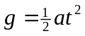
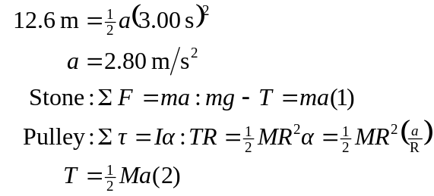

Solve (1) and (2):

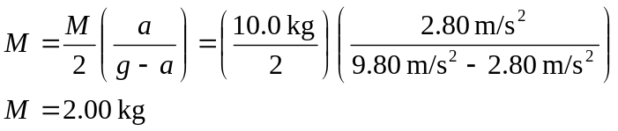

(b)From (2):
